

Integration of WordPress with DoubleClue using OpenID



# Introduction

This guide is intended for WordPress administrators who would like users of their site to log in with websites via DoubleClueMulti-Factor Authentication (MFA) using OpenID.

Requirements:

* WordPress 5.2 or newer with the option to install plugins[1]
* DoubleClue Enterprise Management (DCEM) installation with registered users

Please be aware that WordPress, ‘OAuth Single Sign On – SSO (OAuth client)’ and ‘OpenID Connect Generic Client’ are third party software that are not part of the DoubleClue Enterprise Management. The installation of new versions may be different from the one described below.

# Preparing DCEM to be an OpenID Authentication Server

### Initial Preparation

In order to prepare DCEM to be an OpenID Authentication Server, please see chapter 13 of [“DCEM_Manual_EN.pdf”](https://doubleclue.com/wp-content/uploads/DCEM_Manual_EN.pdf#page=92). You may not need to do anything for this part. Most importantly, check the Issuer field of the OAuth preferences, as detailed in [chapter 13.1.3](https://doubleclue.com/wp-content/uploads/DCEM_Manual_EN.pdf#page=94). It needs to be an accessible URL from your WordPress server.

### Creating an OpenID client for DCEM

1. In DCEM, go to main menu item “OpenID-OAuth”, submenu “Client Metadata” and click “Add”.
2. Enter a Display Name for future identification, eg. “WordPress”.
3. Generate a Client ID and a Client Secret and save them by clicking “OK”.
4. You can access the values again later in the process by choosing the entry and going on ‘Edit’.

# Preparing the WordPress site to be an OpenID Client

Several third-party WordPress plugins exists which allow users to log in via OpenID. We will look at a couple of examples. Of course, it is also possible to use other plugins for this purpose. They will most likely have similar settings. If not, feel free to contact us, and we will try to help you in your particular scenario.

### Example 1: “*OAuth Single Sign On – SSO (OAuth client)*” by miniOrange

1. Download the plugin “*OAuth Single Sign On – SSO (OAuth client)*” by *miniOrange* from [here](https://wordpress.org/plugins/miniorange-login-with-eve-online-google-facebook/) or the WordPress Plugin Search, install and activate it.
2. Click the new item of your Dashboard menu called “*miniOrange OAuth”*.
3. 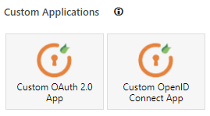In “*Add Application*”, underneath “*Custom Applications*”, click “*Custom OpenID Connect App*”.
4. Choose an App Name, eg. “DoubleClue”.
5. For *ClientID*, paste the value from 2.2.3 above.
6. For *Client Secret*, paste the value from 2.2.3 above.
7. For *Scope*, type in “openid email profile”.
8. For *Authorize Endpoint* and *Access Token Endpoint*, enter “*<your_issuer>*/dcem/oauth” (see 2.1 above).
9. Click “Save Settings”.
10. A new text field appears called “*Get User Info Endpoint*”. Enter “*<your_issuer>*/dcem/oauth/userinfo” (see 2.1 above) into this field.
11. Click “Save Settings” once again. Your settings should look like this:

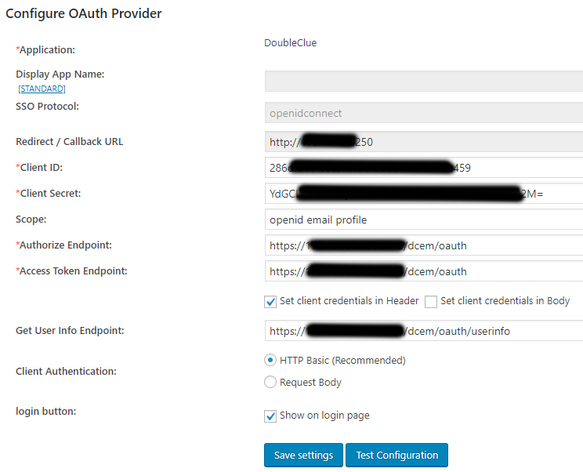

1. Move to the “*Attribute/Role Mapping*” tab and type in “*sub*” for Username.
2. Hit “Save Settings” one last time.

You can test your settings by trying “*Test Configuration*”. If successful, it will redirect to the DCEM login page. You can perform a login, and if successful, it show you a table of user attributes that we send from DCEM. You can use these attributes to set the rest of the attribute mapping settings if you want. Please note that these are only available in the premium version of the plugin.

Once you have everything ready, you will now have a new button in your WordPress login page, by which your users can log into WordPress via DoubleClue.

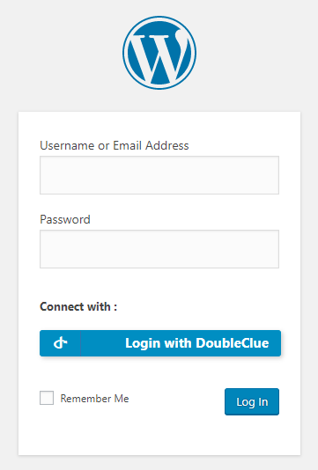

### Example 2: “*OpenID Connect Generic Client*” by daggerhart

1. Download the plugin “*OpenID Connect Generic Client*” by *daggerhart* from [here](https://wordpress.org/plugins/miniorange-login-with-eve-online-google-facebook/) or the WordPress Plugin Search, install and activate it.
2. On your Dashboard menu, go to *Settings*, then *OpenID Connect Client*.
3. For *ClientID*, enter the value from 2.2.3 above.
4. For *Client Secret Key*, enter the value from 2.2.3 above.
5. For *OpenID Scope*, type in “openid email profile”.
6. For *Login Endpoint URL*, type in “*<your_issuer>*/dcem/oauth” (see 2.1 above).
7. For *UserInfo Endpoint URL*, type in “*<your_issuer>*/dcem/oauth/userinfo” (see 2.1 above).
8. For *Token Validation Endpoint URL*, type in the same value as in 6.
9. For *Identity Key*, type in “sub”.
10. Check *Disable SSL Verify* **ONLY** if your DCEM uses a self-signed certificate or does not have SSL for OAuth.
11. For *Nickname*, type in “nickname”.
12. For *Email Formatting*, type in “{email}”.
13. For *Display Name Formatting*, type in “{name}”.
14. Check *Link Existing Users*.
15. Click “Save Changes”.

Once you have everything ready, you will now have a new button in your WordPress login page, by which you can log in users via DoubleClue.

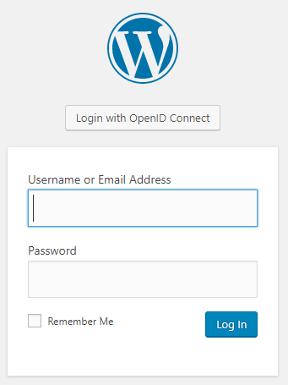

1. Adding plugins is currently not enabled for homepages hosted on wordpress.com under a free, personal and premium scheme.